Nonfiction
Nonfiction is the reverse of fiction. Nonfiction or authentic books are about actual events, people, and even places. Other works could be fiction or Nonfiction, for example, magazines, letters and speeches, histories, websites, and travelogues. While they tend to be both, it is not uncommon for them to be a mixture of both, specifically Nonfiction, with a touch of fiction for added flavor.

What is the difference between Non-Fiction and Fiction?
Nonfiction is a lot more direct. The writer of a piece composed of Nonfiction has specific ideas or facts to communicate, and the authors of Nonfiction typically speak out about what’s in mind.
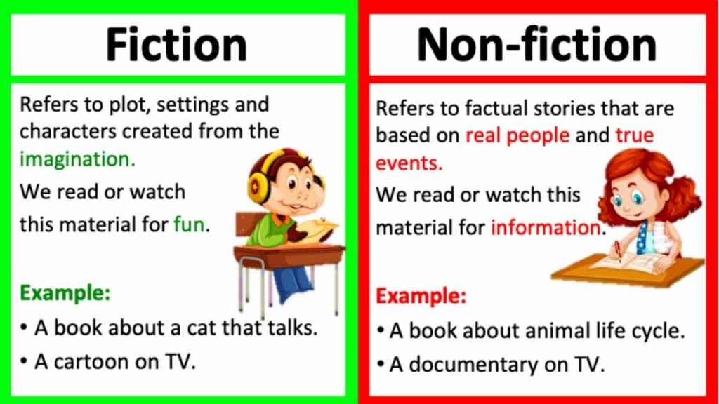
The line between fiction and Nonfiction is blurred in recent times. Fiction writers (writers who write fiction) have written stories that are based on actual stories and characters (Nonfiction), as well as historians (writers who write Nonfiction) have used imaginary conversations (fiction) to convey historical characters’ thoughts. The genre is far superior to fiction in the quantity that has been written, but the fiction genre generally has a greater long-lasting appeal because it was intended for entertainment, and sometimes more average fiction lasts for over a couple of generations.
Each book is designed to influence its readers in a specific manner. This is the case of Nonfiction in addition to fiction, and the fact that readers do not often acknowledge this. I am delighted to have Nonfiction as a genre on this website and Nonfiction since there are some outstanding books available to read.

Characteristics of Nonfiction
Many essential characteristics are common to all nonfiction writing. The most important thing is that nonfiction writing should be based on real individuals, places, and even things. The stories in nonfiction writing must be honest, and if the plot is invented, it’s considered fiction. Nonfiction should also include facts that are facts which can be verified to be factual. In this regard, writers can choose and arrange points in various ways to achieve their goals. Specific facts may be left out while others are displayed in a particular way. However, all attributes should be included in the writing.
The majority of nonfiction books also share the same author’s motive. This is why the writer composes. The majority of nonfiction works are written to communicate or inform. If the writer’s goal is to convey the idea, then the words are always based on real life-like situations. This is why you could say that every nonfiction piece is meant to educate readers.

Types of Nonfiction
Let’s now take a look at two different types of nonfiction. The first type is literary nonfiction, which includes nonfiction written in the style of fiction. It is a term that means literary nonfiction has elements of fiction such as characters and setting, and plot. However, these elements have to be accurate in nonfiction and not fictitious. The stories are designed to entertain the reader and provide information on real accounts. Literary nonfiction can be described as autobiographies, biographies, and essays.
The other kind of nonfiction is informative. Informational nonfiction aims to inform or explain the concept or issue, and the purpose of this type of nonfiction is to give the reader facts. Informative nonfiction is composed of articles and interviews.

